**Phase 3: Implementation of Project**

**Title: Natural Disaster Prediction and Management**

**Name:** Salman Faris .R

**Reg No:** 311623243044

**Department:** B.Tech - Artificial Intelligence and Data Science

**college code :** 3116

**college name :** Misrimal Navajee Munoth Jain Engineering college

**Date of Submission :** 23 - 04 - 2025

**Objective:**

The aim is to bring to life the essential elements of the AI-based Natural Disaster Forecasting and Management System, following the concepts and inventive strategies introduced in Phase 2. This stage involves creating AI models for disaster prediction, risk evaluation tools, alert systems, and user-facing platforms, along with integrating preliminary data protection mechanisms.

**AI Model Development**

Overview The system leverages AI to anticipate natural disasters such as earthquakes, floods, and heatwaves using algorithms trained on both past and live data.

**Implementation**

* Earthquake Prediction: Use seismic datasets (e.g., USGS) to train models to detect early seismic patterns.
* Flood Prediction: Analyze rainfall patterns and water level data using Random Forest or LSTM models.
* Heatwave Prediction: Use weather parameters (temperature, humidity, wind) to predict heatwave alerts.

Outcome By the end of this phase, the AI should offer basic disaster predictions, such as issuing alerts for high flood risk, possible heatwaves, and preliminary earthquake risk based on data.

**Alert and Notification System**

Overview The system must notify users about disaster risks using timely alerts through various channels.

**Implementation**

* Multi-channel Warnings: Disseminate alerts through SMS, mobile applications, and email.
* Safety Instructions: Notifications will contain relevant evacuation or protection measures.

Outcome Users receive early alerts based on AI predictions, improving disaster readiness. Alerts are simple, multilingual, and include safety actions.

**Web Dashboard and User Interface**

Overview An interactive online platform will serve both general users and authorities, showing current threat levels and predictive analytics.

**Implementation**

* Geo-Visual Map: Integration with Google Maps API for visualizing danger zones.
* Building Risk Evaluation: Allow users to assess structural vulnerability to seismic activity.
* Language Flexibility: Initially available in English, with multilingual support planned..

Outcome The dashboard becomes a real-time decision-support tool for communities and response agencies.

**Data Security Implementation**

Overview Given the sensitivity of personal and environmental data, security measures are essential from the beginning.

**Implementation**

* Data Encryption: Basic encryption will be used to secure all inputs and stored details.
* Authorized Access: Restrict access to secure data repositories to verified personnel.

Outcome The platform ensures privacy and data integrity for all users and partners.

**Testing and Feedback Collection**

Overview User and technical testing will validate the solution and gather insights to shape future improvements.

**Implementation**

* Pilot Trials: Conduct trials in areas like Chennai and seismic zones in the Himalayas.
* User Feedback: Collect data on alert clarity, system functionality, and ease of use.

Outcome Insights from users will support model refinement, feature enhancements, and improved engagement.

**Challenges and Solutions:**

1. Model Precision Issue: The AI system might occasionally miss or misinterpret patterns. Remedy: Combine statistical models with AI algorithms and continuously retrain on updated datasets.
2. User Engagement Issue: Alerts may be overlooked or misunderstood. Remedy: Simplify messages and include voice and visual aids for broader accessibility.
3. Real-Time Data Access Issue: Not all data sources are readily available. Remedy: Use test datasets for now and integrate official APIs (IMD, USGS) in upcoming stages.

**Outcomes of Phase 3**

1. Operational AI modules for predicting key natural disasters.
2. Reliable notification system for disseminating warnings.
3. Real-time dashboard for viewing risk data and building assessments.
4. Secured user data through encryption.
5. Feedback collected from early users to enhance development.

**Next Steps for Phase 4**

1. Enhance prediction models with real-time data feeds.
2. Expand support for multiple languages and voice output.
3. Establish collaborations with emergency services and local governance.
4. Add visual analytics and trend monitoring features to the dashboard.

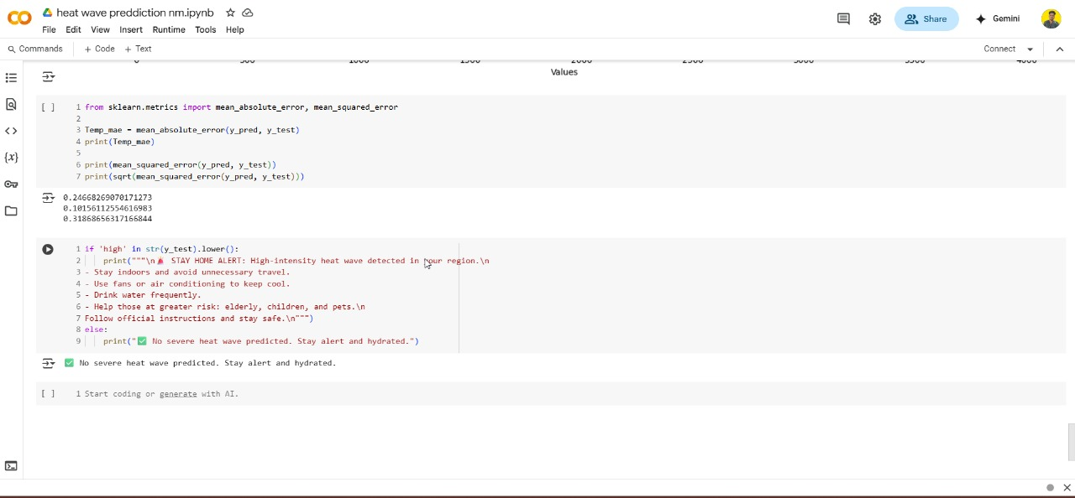

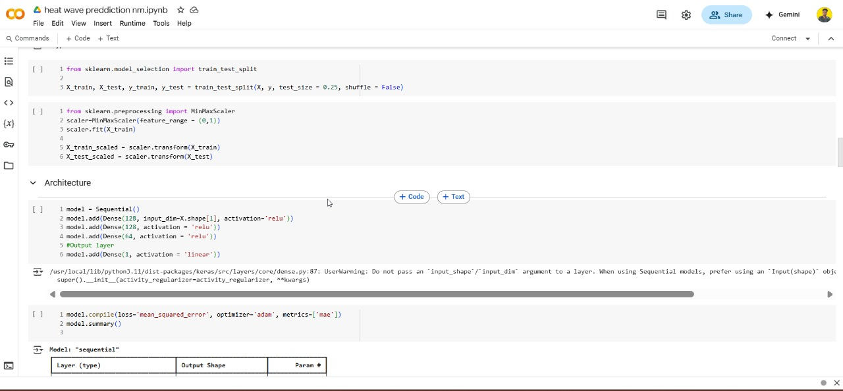

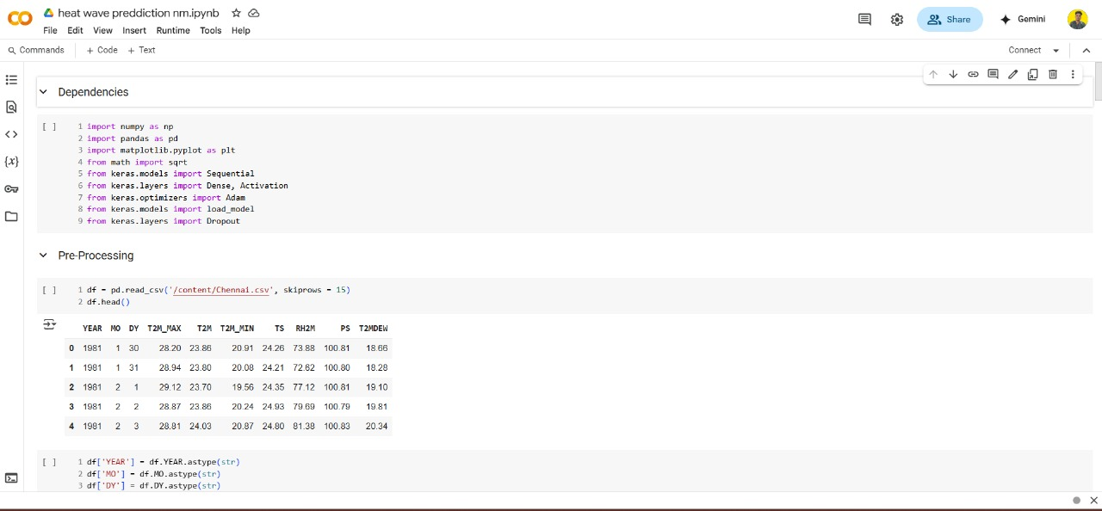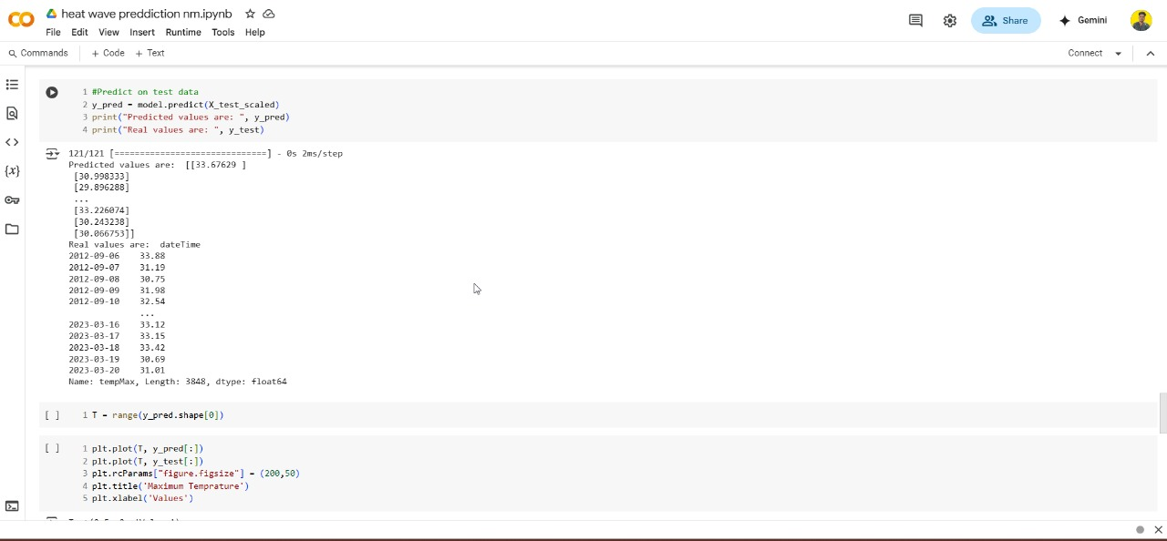

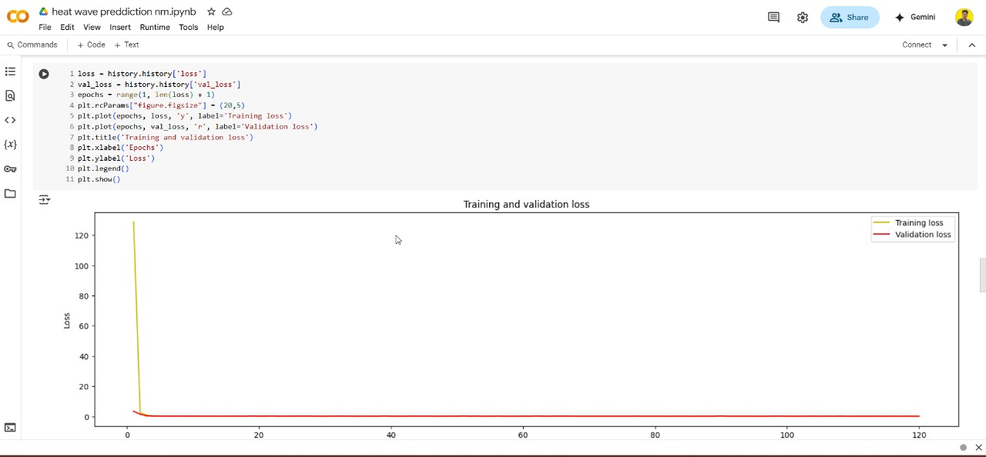

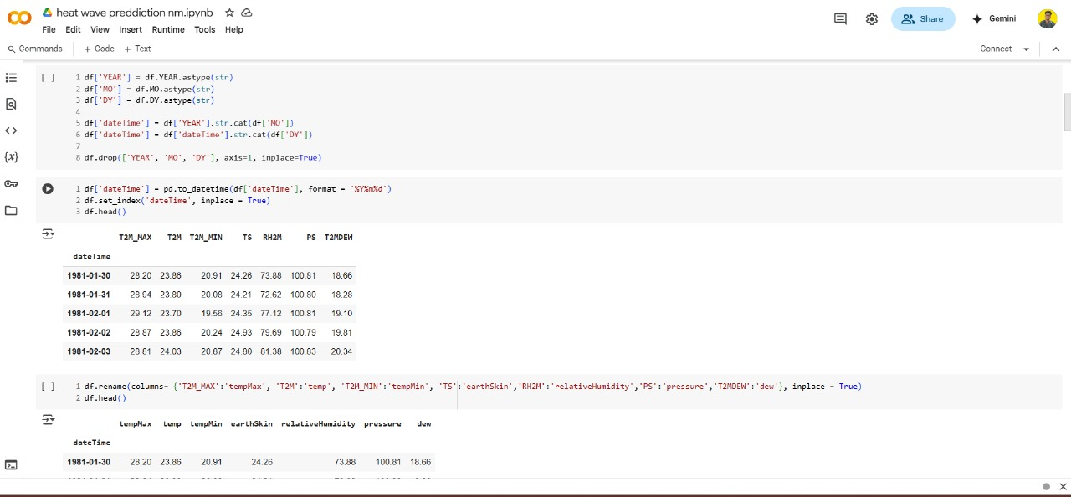

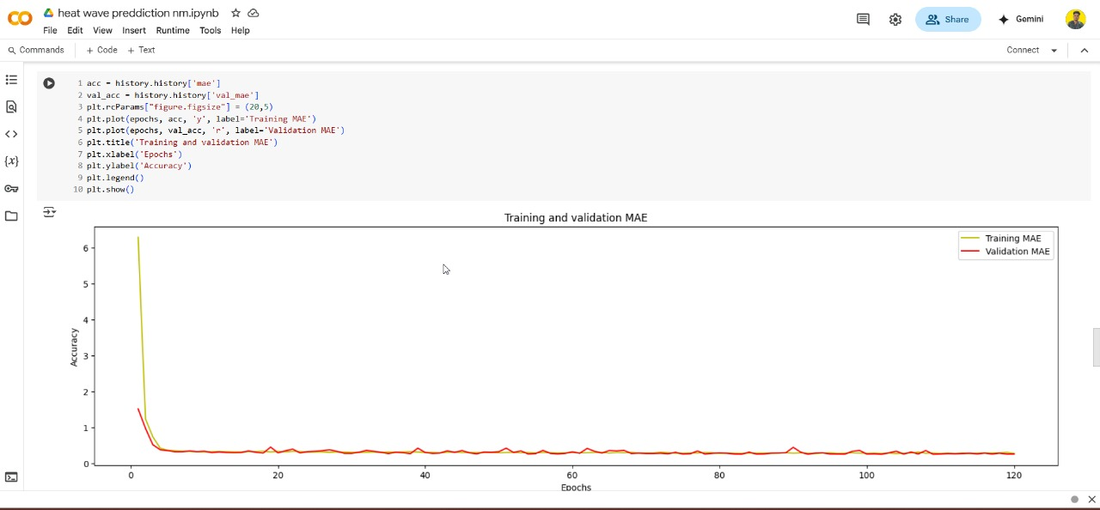

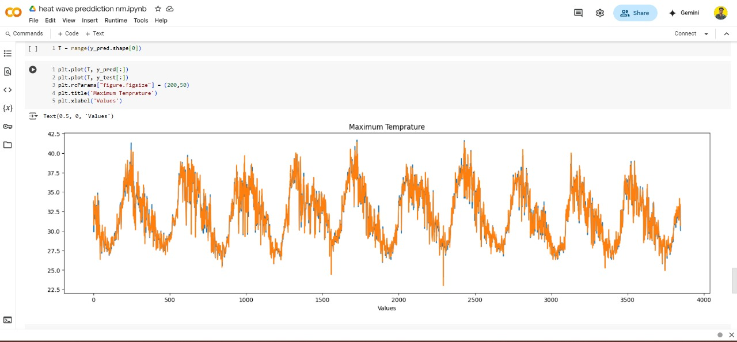

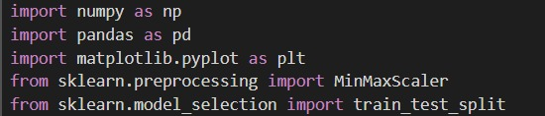

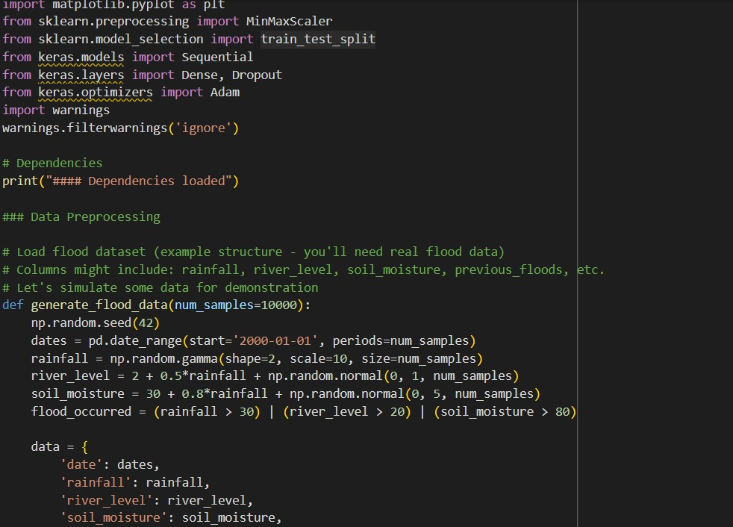

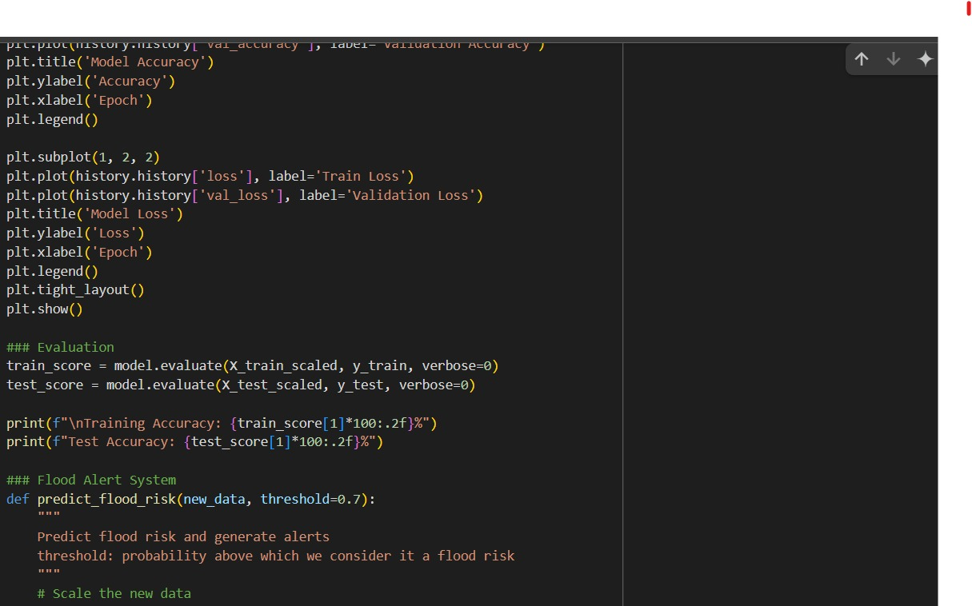

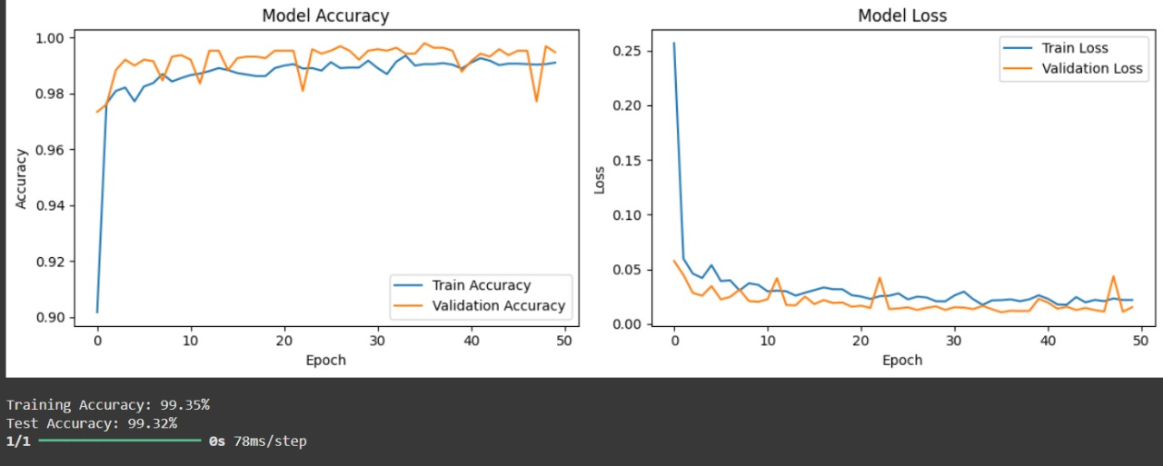

**Team Members:**

1. Mayuri Thilak - 311623243030
2. Sidharth R – 311623243050
3. Mayuri Thilak-311623243030
4. Praveen S- 311623243037